Preface

On July 10, 2019, I was shell shocked to learn about the passing of Tracy Twyman. I'll always remember this day as one of the defining moments of my life. I've followed Tracy's writings for a decade and conversed with her on a few occasions. I also declined the invitation to join Nicholas de Vere's Dragon Court (Tracy was heavily involved with this organization). Maybe my kingdom is not of this world. Now that Tracy was gone, something in me wanted to tell a story of my own occult experiences and musings. Finally, M Elegies was born.
As I kept writing down those strange, dark, and highly surrealist imaginings, I couldn't help but feel a very palpable living presence in my poems. There were times when I felt the poems were becoming doorways or portals into other realities and dimensions. I think my poems are designed to appeal to the subconscious mind of the reader. I wanted to convey a sense of mystery and darkness lurking behind the facade of our everyday existence while simultaneously giving the reader a glimpse of hope and transcendence of pain. As Tracy would say, we need to go beyond the known realm of existence.
M Elegies is a wildly imaginative journey through art, myth, star lore, ancient and prehistoric civilizations like Lemuria and Atlantis set against the theatrical backdrop of lush tropical nature. In essence, I see this collection of poems as a love letter to All That Is.

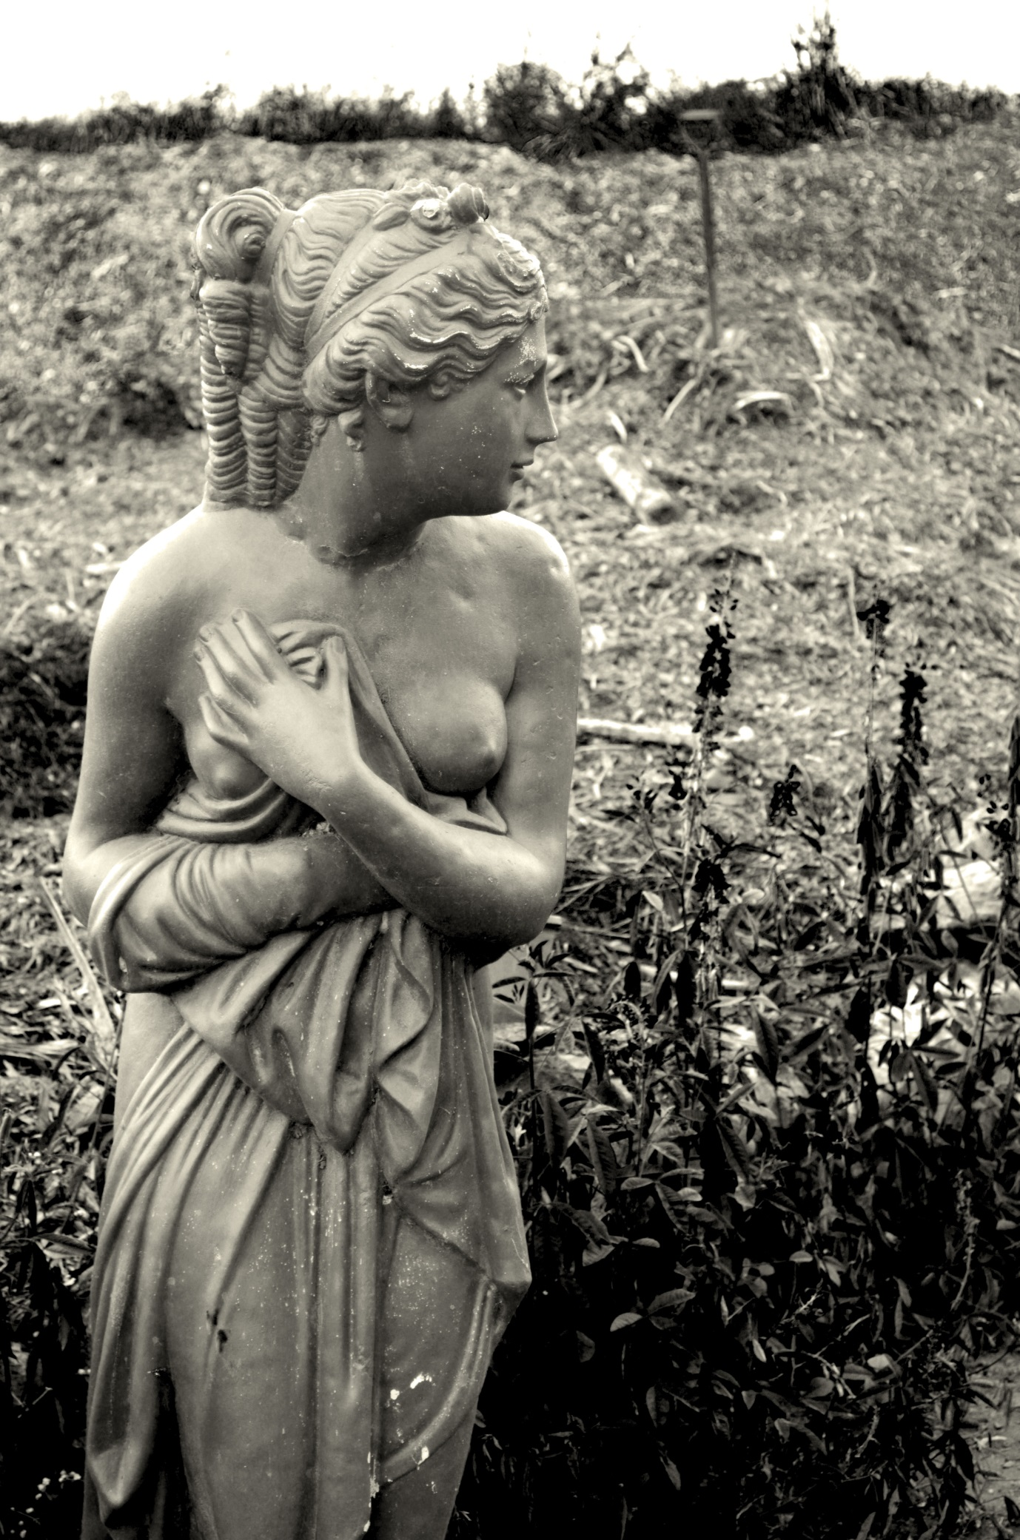My Mellifluous Melissa
My Mellifluous Melissa
A bee is a princess of Venus
I'm watching another sun-robed maiden
Ennoble a marmalade rosehip petal
Every garden is a cathedral
The myrrh of a golden fleur-de-lis
Six-starred stained glass springs
Blue violets
Hush

Meritaten and Meketaten
(For Patrick Zeigler. Thank you for birthing my heart)
Does one miss the sea after all?
Now that you were all flesh and bone
...finely woven from the Sun...
Swooning westward each day
Did silky onions gleam in the moonlight at Amarna?
Did Maat pierce your rib cage with each sunrise?
Did a Libyan glass scarab blaze like a rod of flame?
The desert rain listened in on your trances
A cauldron of diamond light inside your fortress city
Funny princesses -- you were so artistically caged
Did you ever come back from the Milky Way to finally
Sink under the ocean waves, that dear old starry soup?
A Maldives holiday? No? What about Florida?
Or go for lonely walks in some world city and
Sit down with a cappuccino, incognito of course
While listening to a fountain nymph
Anonymity at last: what a celestial life
Every gentle oak dryad still recognizes your rank
What of crystal tipped obelisks and limestone temples?
Such things wash off
Like malachite eye shadow
Or white sand from the beach
Life washes off

The Einstein Cross
The waxing moon is a dull potato sack
Over shimmering bean green waves
Wanting to die is a communion one takes daily
Pain is the wafer, lethargy is the wine
Life and death, two curved sinuous lines in the sand
I sink under the sea foam over and over again
Baptizing myself with Medusa's sweet furious blood
Still the sea is gentle, all encompassing, all forgiving
Neptune's zero point chalice
I am everything, I am everyone -- my head is now cut off too
A winged white horse appears in the mist
Or is it a constellation of golden clouds against the blue infinity?
A pillar of luminous light pierces my spine
The horse opens its mouth
A glowing blue cross
Is turning me into a tree
I am solid now, all bark, fungi, and sunlight
I am a walking sycamore tree
Rooted into evanescent stellar sounds

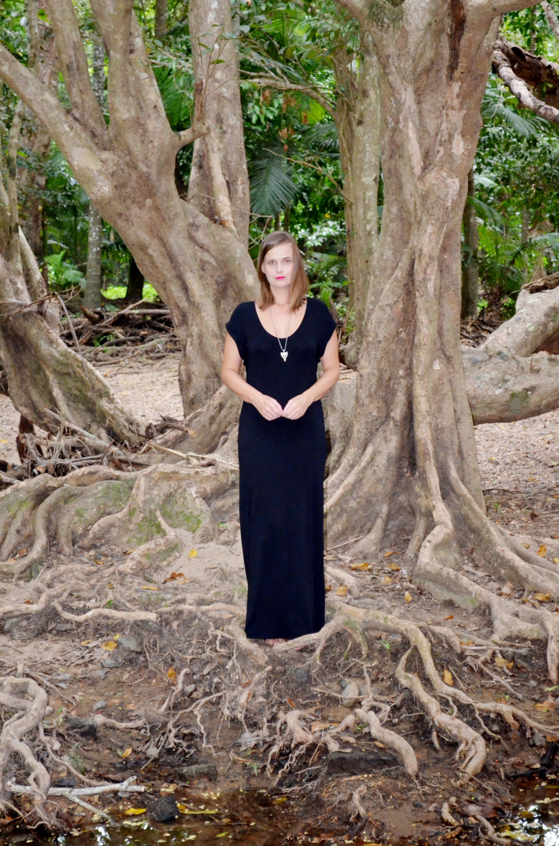

The Evening Star and Black Cockatoos
The unceremonious screeching of black cockatoos
Salutes the honeybee
That feeds the flowers
The bark and the dirt
The deep green sea is gradually knitting
Starlight, life and black feathers in
A purple thundercloud of
Kyrie eleison
The hesychast heartbeat of ferns
Systole, diastole
Brings forth
A sudden effervescence of the honeyed night
From the inner treasure house of heaven
Neith, the mistress of Sais,
Has put a blue veil
Over our red soil and lavender hills
Morning Star,
Open a way for me
To return in peace
Keep my black cockatoo feathers
On a fragrant floor of tamarisk wood
Shatter me into a thousand sea horses
So I wake up with
A golden spine from Heliopolis

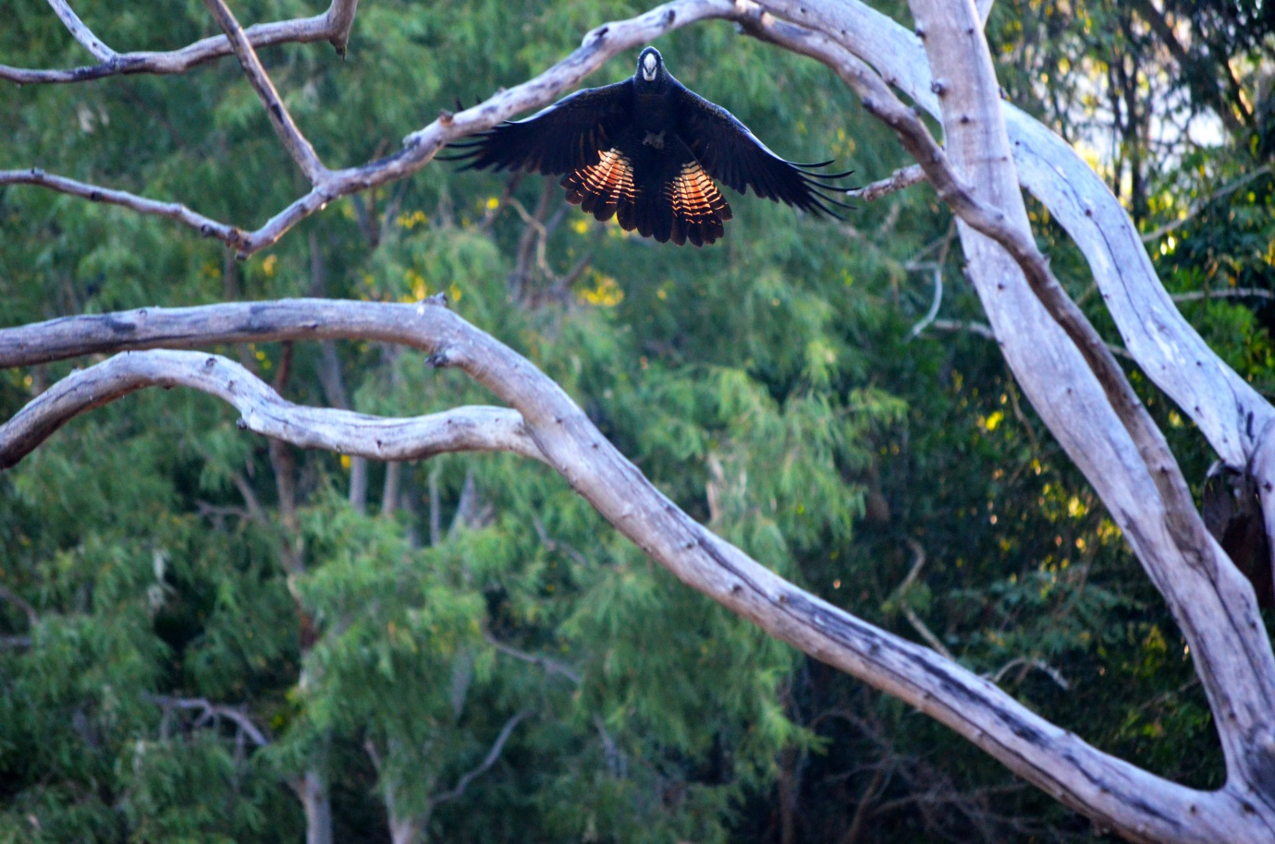

Water Trance
"Silence is the general consecration of the space.''
(Herman Melville)
Every river whispers secrets of the land
...tragedies, future-past...
Set has scattered many undeciphered
Hieroglyphs of the Fates
...the sacred scrolls of destinies, future-past...
To the Nubian winds
The black river is entering the silence of the space
The Sun doesn't shine at midnight
Now Helios is a broken marble faun
Whom does the Grail serve?
The stillness of the river is preternaturally shrill
Now fragile filaments of the web are torn
Power of the spirits
Power of the crocodile
Power of the immortal frangipani flower
Power of the iridescent dragonfly
Now rivers must become Edenic again
The holy places of the tabernacles
Of The Most High

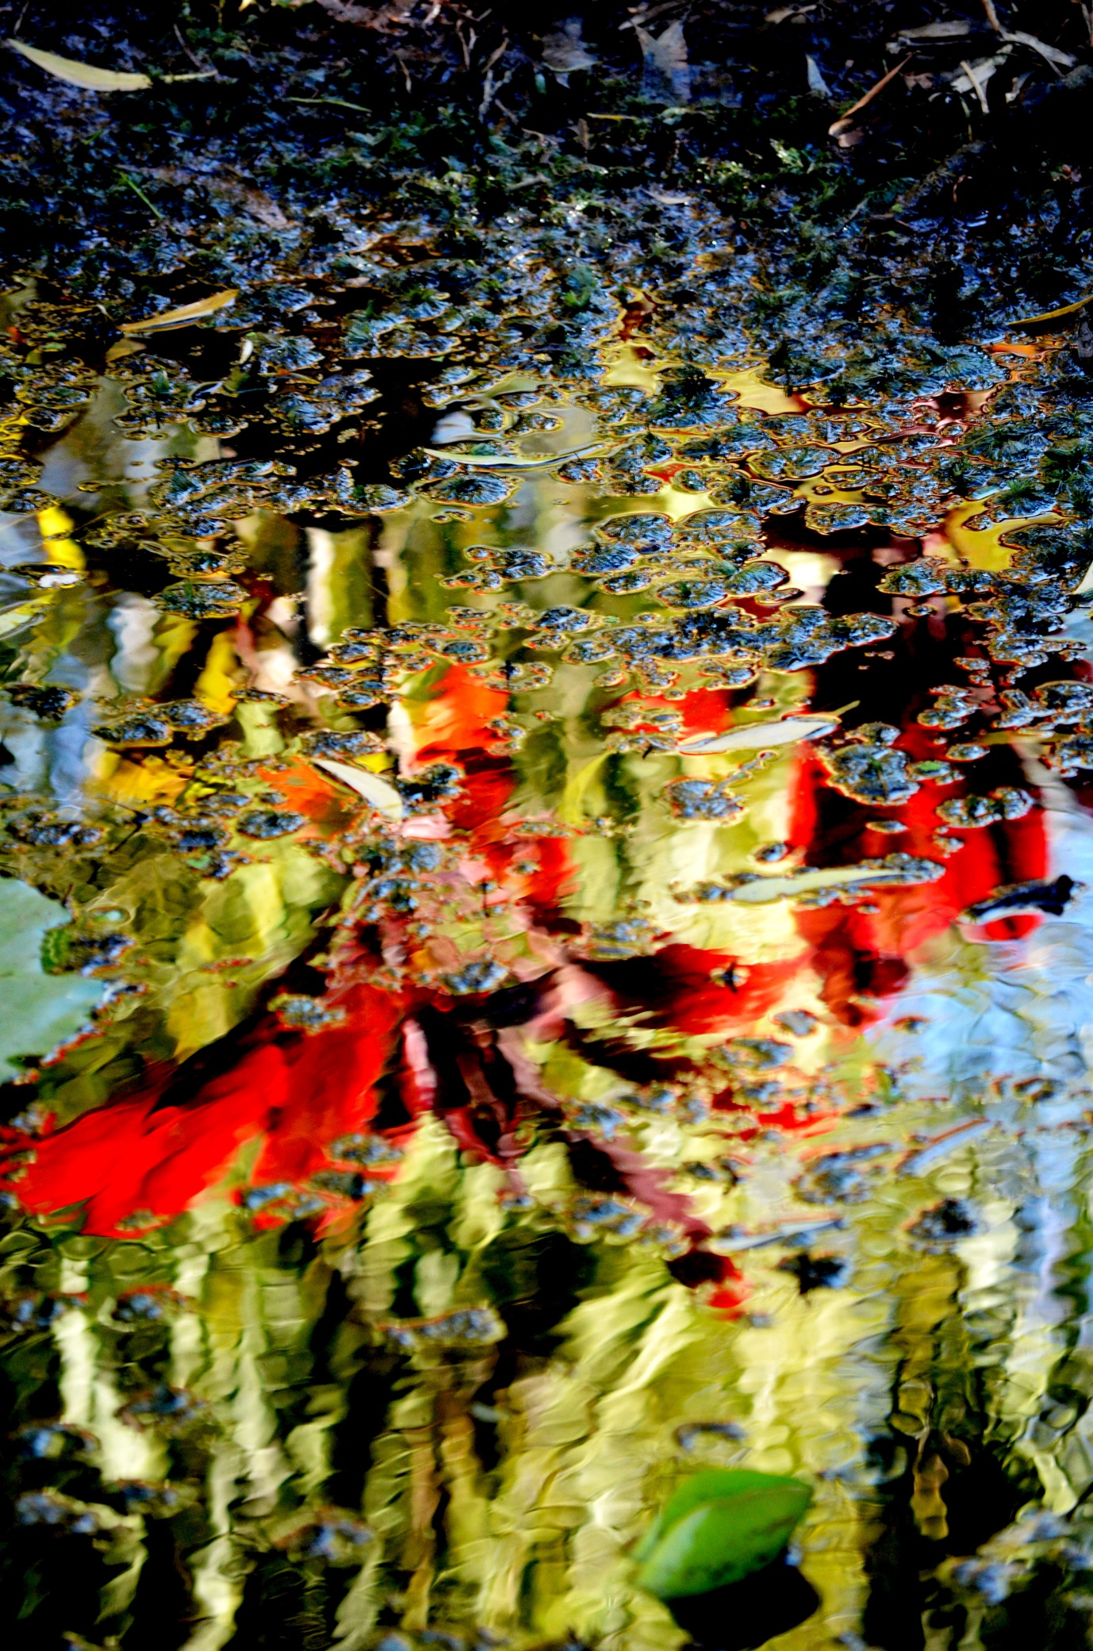

Tropical Flowers
Those shimmering folds of red, blue, purple...
What fine stone powder
Has painted your siliceous pictograms
The witchy, supercharged plenum of your fragrance
Is so white, Doric and hazy
Like memories of the future
Or blunt like a bedstead of iron
In a moonless lost world
Everything is perfected
Each tiny circle is a puma head
Rising out of an apocalypse of fire and water
Only stencilled old temples of lush flowers
Bleed and beam through time

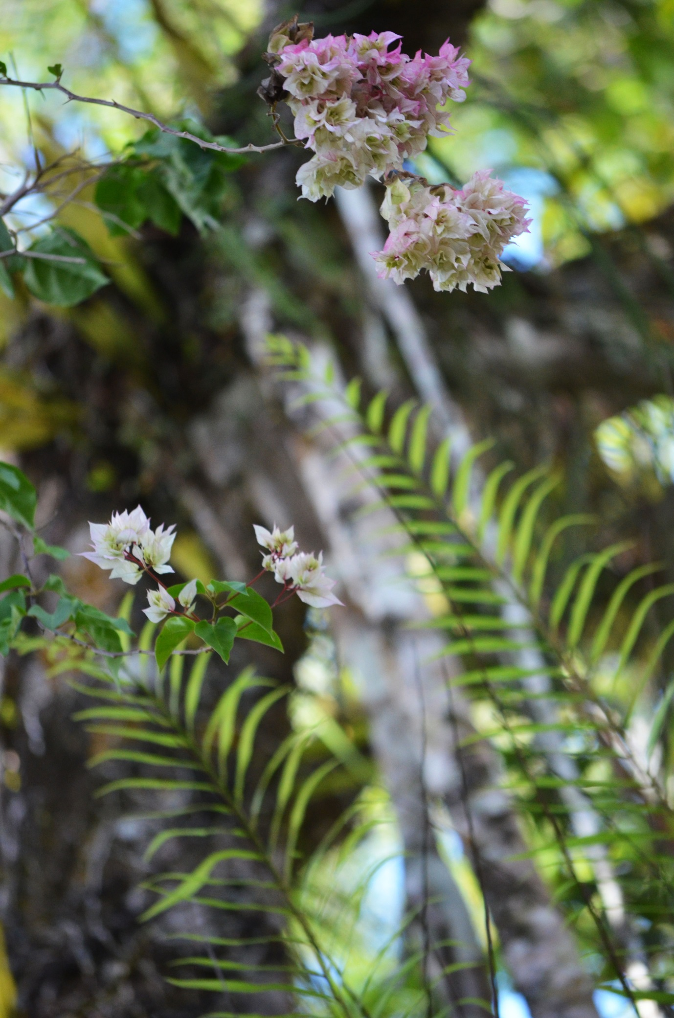
Baby Python and the Death Mill
Under the cover of darkness, peaking his tiny head out of the stairs
The serpent is practicing beauty
Absorbed in a cold nuclear blast of his skin ornament
The dry husk of me spirals into charred deathly bed sheets
My yellow corn is harvested and I am fed to the pigs
An obscene dance begins -- it's quite baroque
Death will cook you until you crisp at the edges
Like corn bread
You are pummeled, kneaded, baked by the fire
Every good maxim falls out of the sky like a dead black bird
Then you feast on a cheese platter
Of your own worn-out stories, all moldy pages long out of print
The wine turns back into sour grapes
The purple flowering vine of your death
The telephone light line is off the hook
The default dream is still scanning the horizon
The theatre of the Grand Guignol opens her legs
The nightmarish clock stops at infancy or dawn
Every cell quivers with the venom of life once again
What a fascinating engagement

Lamentations of a Pale Horse
Untethered, uncorseted
You slowly wobble
Towards me
Spinning with the Earth
The horse and the blue mist chronicle rock
O how gloriously you fuse
A white spectral contour of melancholy
Accompanying
My every evening walk
Past the strawberry mango tree
Where a pale horse
Is haloed in the punctured silences
Of scattered paperbark pieces, all undreamed poems
And sun ravished, hennaed grass
Your eyes lament
Every molecule of pain
Has become a granite vein
In the landscape of my soul
Now I am perfected
As a candle of violet flame

Mem
Poseidon is playing with mercurial colors of the sea again.
Savagely undulating waves of green putrefaction
keep the tides of life in suspension.
By the shore, a dead purple fish is gaping at
the palor of a grey leaden sky in disbelief.
Is it all? Is it all?
Now there is a moment of prudent silence
as sadness is dancing in dry leaves,
all pulsating crystal rainbow rays.
How many invisible life-lines are woven together?
The sea, trees, black dogs are slipping away
into a starless primordial beryl soup
filled with yet unknown and unseen life trajectories and tombs.
I see a wisp of cigarette smoke. Poseidon is well pleased with his day.
Amphitrite, an august Oceanid, is feeding
regal dolphins and meek sea turtles in the azure waves.
Every bleeding heart is torn apart with unimaginable pain
and cleansed in the dew of the stars. Light as a feather,
the heart is air-borne.

The Path of the Star
The river is dark and insufferably lazy
It reclines against the silky blackness of itself
To receive the dusk's embrace with
The witchdoctor insects voyeuristically trilling
A brilliant star appears over the hills
Seven white feathered birds curtsy with no bonnets
Seven star-tipped thought arrows
Seven blue star rosettes over the land
My wrists are pierced with tremendous pain
Black river fish spirits surround and ambush
Ceres with their celestial hooks painted with dots
The black river is a serpent
Always hungry for death
The black river bloodstream churns out
Thanatos and Guernica horrors
With every pale moon ray
Take it all to the warm basalt rocks
By the shore
Bury it
Bury it

Tiepolo Pink
Silvery greyhound clouds are melting into delicate splashes of Tiepolo pink
Before the cobalt blue sky plunges into a stormy sea
The earth replies with a monotonous buzzing of crickets
As if a thousand interstellar Taiko drums salute the twilight with a battle cry
Ariel speaks:
"Have you offered a fiery agate to the spirit of my lizards?''
"Have you put a blue gemstone in a pond in honor of my peacocks?''
"Or left a circle of thirteen black shells by the ocean shore?''
Restless pale horses seem moon-lit from within across the field tonight
Ariel's sprites burst out laughing in female voices by my river
As my thoughts become confused by invisible lyres in the wind
I recognize a painfully familiar orchestra from a distant star

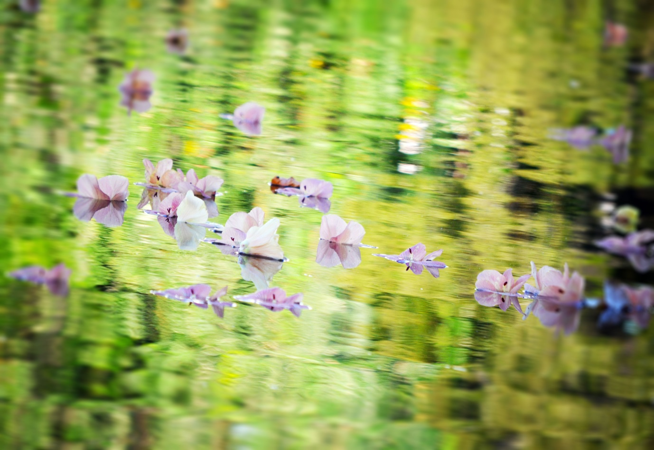

December Heat
What singed griffin feathers
Make
And un-make me
When I enter the forest of my dreams at night?
Tigers, tigers!
Red silk finely woven Persian arabesques
Jacaranda tree petals now marry the burnt grass
What does this Kalika-esque blood profusion prophecy?
A magus is always a sacrifice
A poet is nailed to his own soteriological
Tree arc of ink and despair
O dulcet breeze and cricket song
God is far and we are the next best thing
Let the white sun fall to pieces like shattered glass
Hear me, panthers in my dreams
Lap up all my blood platelets and unpeel my skin
Before the monsoon comes in January
To turns the world into
A prehistoric emerald shrine

Emerald Dreaming
If God was a hideous orchid
The rainforest would be his shrine
A Satan's church
A glittering mechanical green capsule of
Spirals, patterns, sets of organizing energies
A thousand focused sunlight lasers
That lock the souls into cause and effect
Nature is full of patterns
Once a victim, always a victim?
The music of the spheres
Condemns us thus
How many times does a tree branch?
There is a respite from the Terror
In the simple physics of water
River systems and Gondwanan trees
Fusion and fission
Isis and Nephthys
Our scarlet wounds are etched in spirals
In the Emerald Dreaming of spirals
We are airborne, Osirified,
Crowned as co-creators of
All That Is

A Thought Arrow
A thought arrow is a purple wing which
Heralds Judgement Day
Over Trinity Bay
A thought arrow is a gift of Avalon apples
To the fountain nymph by a shopping mall
Holy, holy, holy is the Lord
A thought arrow is a vine embroidered obelisk
A ladder of light
An invitation, a plea for help
A swan-white harp
Inescapable as a fixed blue star
A thought arrow serves
The Grail
The Ineffable
The M

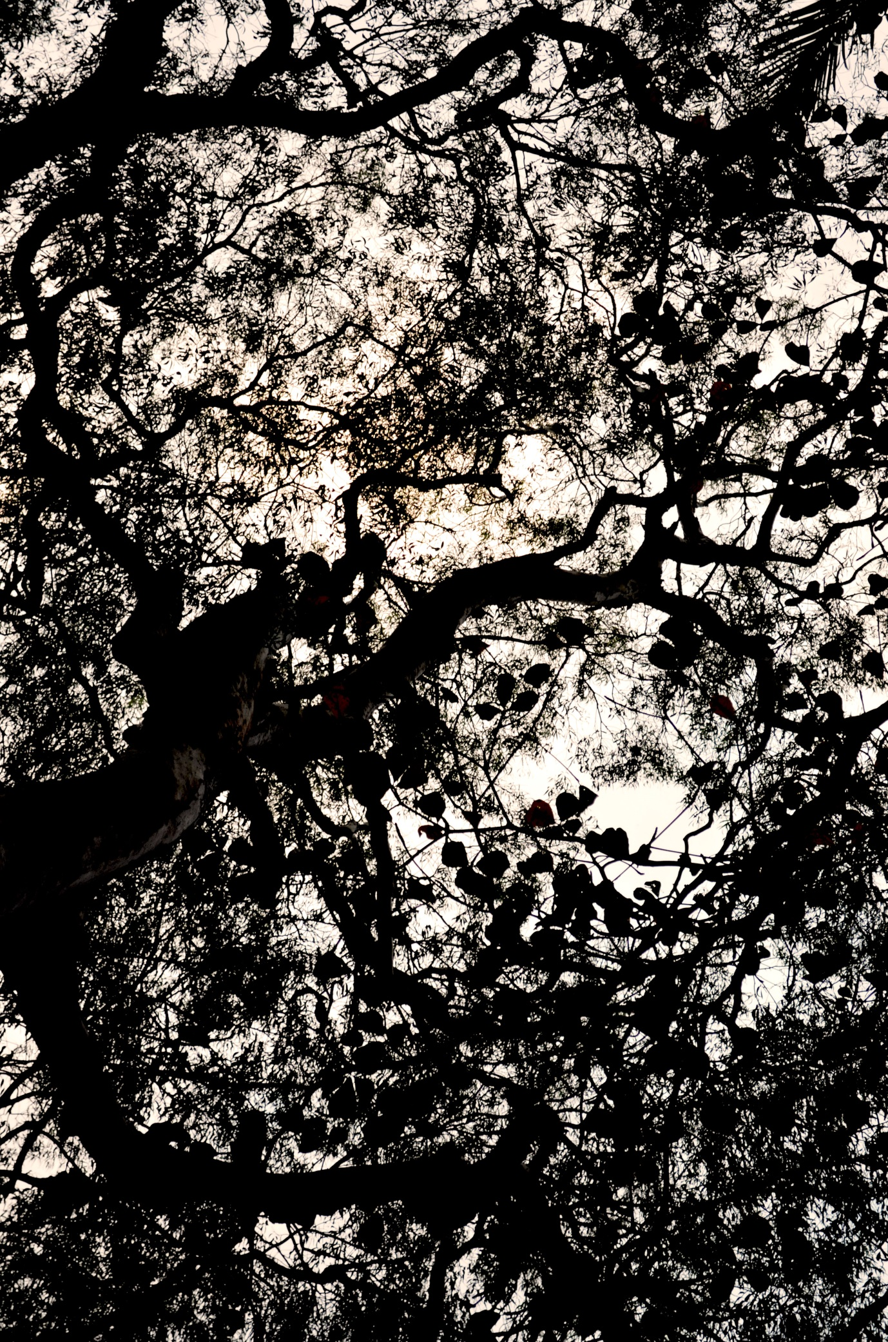
Ad Triangulum, Ad Quadratum
A sphere-point enneagon of one's last breath
Will shatter cosmic tilings of the sunburnt weary heart
Into a cup of mercy
...unfailing and royal...
Now blessed by Jupiter
The shepherd of the golden stars
A Wedgwood blue sky
Has turned into an azurite psychomanteum
By the sea
O immortal divinities
Make me live forever
Walk me through a door of ivory and gold
Wake me up with Ra, Master of the East
Osiris, know that I am
Pure, pure, pure
Given life by Isis,
I walk through the flames and create my own light
From the twelve realms of the night
Up comes an iridescent chameleon
To lavish an Apollonian palette on me:
Sun King gold and Olympus white
Proud purple, buttercup yellow and seashell pink
I am wearing a white silk organza shroud
They have turned me into a swan
Gliding across the invisible river of Saraswati
A blazing star silent and majestic
Entombed in the beauty of all things
That are, have been or ever will be
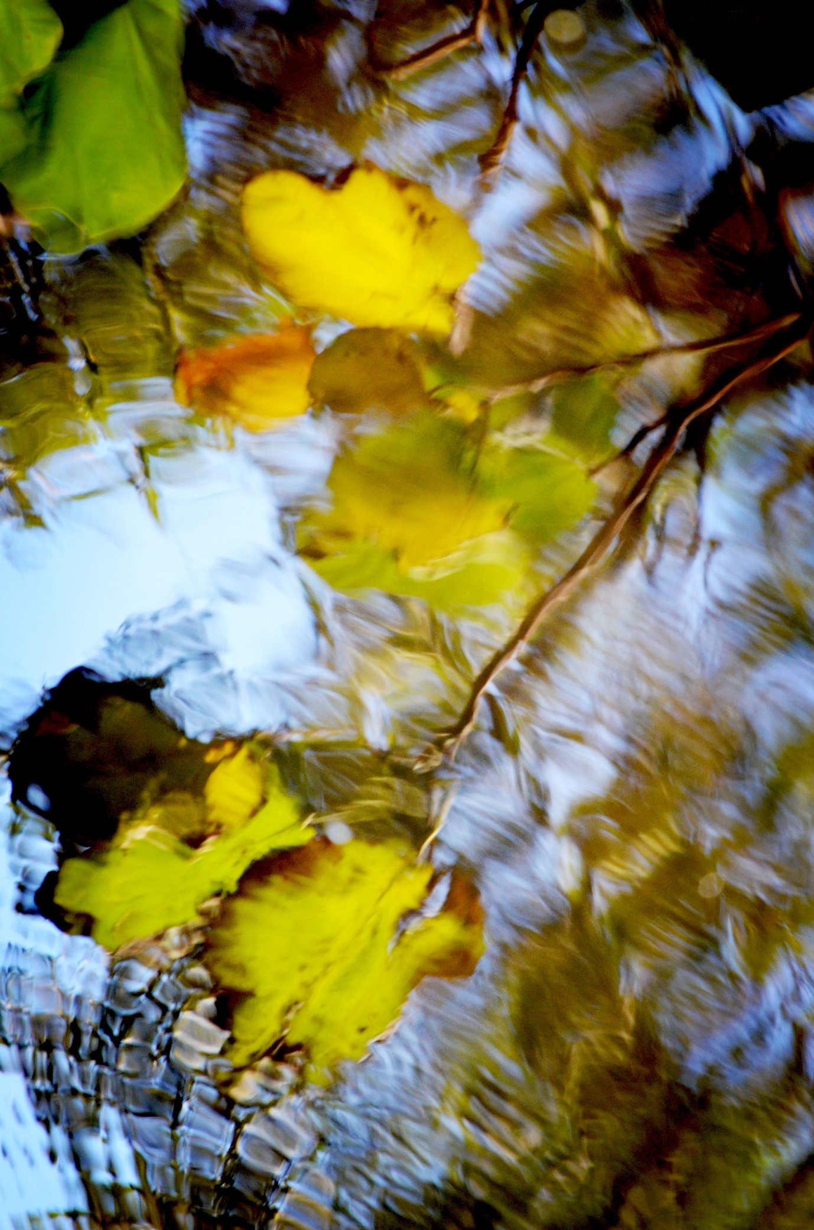
November Love Gift
Today the old pioneer cemetery is a warm papery nest
Fresh hot cross buns are flying red banners at each Woolworth's
Even Archangel Gabriel is in awe at his own trumpets over Trinity Bay
Another world is peaking through Art Deco hotel facades
Every glorious purple vein of every frangipani flower is
An arc of long forgotten light
It is a love-love-love November gift
Must I be seated between a lion and unicorn?
Must I open my Book of Hours and let the spell escape?
Rose, violet, pea, physalis, calendula, daffodil, strawberry,
Bindweed, nightshade, mugwort fly over the land
O pale lavender clouds -- what am I to be allowed to see this?

Anatolian Dreams
''Go and catch a falling star.''
(John Donne)
St Barbara, a poor white gloved icy ingénue
Has long been a dusty piece of Black Forest wood
That grew out of the ashes of Sibylline books
The black stone is gone from the Palatine
Only infinitesimal phantasmagoria of the sea
Dwells deep within the grave mound of the soul
While carrying a torch clothed with the sun
Nikola Tesla still feeds a pigeon every day
It's an aperiodic dolphin atavism
Awakened by an unknown lyre
It drinks virtue from a moon beam
Only Saturn, the awakener of lavender hope,
Silently watches the humble pigeon
From the depths of our star fed earth

Golden Wattle Flowers and the Wolf Web
The world is spangled green and gold
Against the blue dome of the sky
The newborn spring sun is still a death head
A bright white inflorescence of pain
Is a Christmas garland
For my womb coral tree
My shining uterus horns
Never to bleed
Life and death
Howling wolves, come into my dreams
Turn the black coral tree into
Deep petrified prehistoric roots in the
Scarlet red silence of the night
There is a grey web of wolves and ophidian moon blood
My body is struggling to shed so hard
Beneath a yellow carpet of daytime citrine light
The wolves will eat my dead blood in a circle
To breed black moths, pain moths, desert moths
Guided by a bee melody, the wolves will water
Another tree
It's a perennially flowering fig tree

Incalescence of Backyard Chickens in Fiery Sunsets
The bird feet fall upon the grass like autumn leaves...softy, softly
The red sun disk is degraded into a void of anaesthetic blackness
I see cinnamon and orange-yellow chicken feathers:
Each feather is pencilled with amber glow
Golden brown breasts are tipped with honey drops
Or hard feathered luster of yellow wheat
My hens, must you fall silent like Philomela?
I remember you pink like cooked salmon
Clucking like half-forgotten childhood prayers
What Jacobite feathery heresies am I a warden of?
What crimson powder have you left me with
As the night envelops this ancient red earth land?
Only the potentate of a new sun
– Chevalier Rooster in his black tunic –
Will herald a gentle seraph with his sentinel cry
My tongue has been cut off
I have learned to weave myself into everything in
My bedroom with many mirrors
My heart is filled with mahogany softness of a plain bird
Dear cicadas, now lull me into oblivion in a grove of Pan
Tonight I am sea mist, boneless at last

The Heart is a Parrot Wrapped in Copper
Angel mounds bedevil my dreams with
Sunfower smiles or miles of emerald sugarcane fields
And a pumpkin profusion of stone monstrosities
Their reveries of the past steamroll into the future
...diamond-shaped and star bejewelled...
A burial chamber of crickets
Guards a green parrot heart wrapped in copper
It's a stubborn thing that doesn't give up
Small bones of the familiar brown river
Melt into a treacherous hilly horizon
The savage figurines of tropical leaves
Dance to the beat of a diorate bull head
...an old tapestry of jackal and dog bones...
Mummifying linen of lunar rays
Cover the crimson wound of each waratah flower
The Aswan granite vein of light is buried in black soil
Millennia old cords between hearts are woven anew
In the black tar of the whispery night
The world is chopped up and cast aside again
Only indigo silence and midnight terrors remain

Marigold
The adept herb of the sun
A radial photon machine
Exploding with the light of a thousand suns
Beyond our sun, a solitary star
Marigolds, hungry lion mouths
Gaping at my Mary blue habit
Should I let your fires
Inside the dreary catacomb of my heart?
Proud yellow, orange
Red and maroon blooms
Are you not afraid of my darkness?
For I'm owl-born
My Minerval sharp talons and curved bills
Feast on the soul of everything
I'll crush your sun kissed petals
For my Lilith potions and charms
Beware, beware
Of my unquiet shade passing by your garden
I am the blackness and the madness
That guards your life-giving gold

The Impossible Triplicity of Seahorses
The impossible triplicity of seahorses
Flying towards
The ocean floor
Bleached seaweed burns away my sorrow
Painting my voice aquamarine

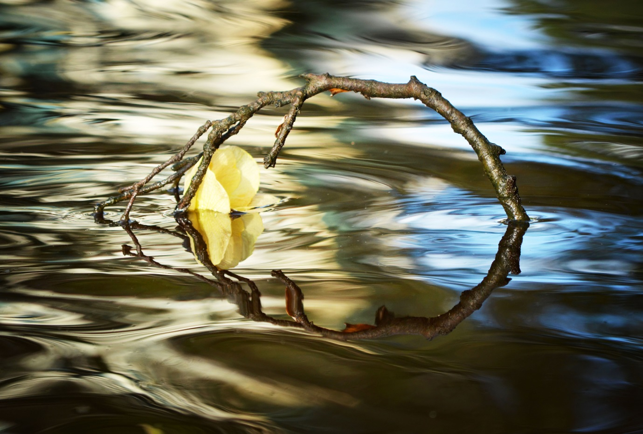

Watching Aldebaran
The sweeping lunar curve…
Away, away with you
Ambushed by big brown wet tropics frogs
I'm turning into shimmering dewdrops
To melt into a jet black sky between
The bloody horns of Taurus
Dark fragrant stillness
Always incinerates my bones
Like a sacred mollusk from Tyre
I'm bleeding purple daemones
Wrapped in bull hides and codeine
I'm riding a red deer
My black pain moths
My mummifying starfruit oblivion pills
Fly straight into
The Diamond Eye
My heart is a dictionary of scripture and myth
Burn it to a cinder, God's Star
Feed it to my frogs and nephrite dew

The Storm
before another wet season storm came
(and the sky was still opalescent purple)
they brought in a batch of baby chickens
a little girl in a rose dress smiled so brightly at me
by the river bank
right where fiery orange petals of my jacaranda soul tree
were peeking through the carnage of ashes
in a stern stone circle. a tropical rainstorm is always
a sacramental thing because it's
almost meteoritic or auriferous
we'll breathe in healing scattered light of
ions and plasma never-never worlds
during a gala premiere of the country chlorophyll dance company
the ferns will be glistening with their best rain tear
jewels. pieces of wet paper bark satin will anoint
the ground with wishes, hopes, spells, incantations
yet undreamed and unspoken. time is only a dream
life giving spells of melaleuca trees, rose dresses
baby chickens is another hidden vein of gold
it's less theatrical and dionysian, yet it's the memory
of fire light that counts. the remembrance of a stone circle
before the black starry water serpent. you've seen
an offering of bright orange petals by the river of time
we are a cemetery of people and places left behind

Glassy Ibis the Oneiropompos
There you sit on an outcrop of black volcanic rock
Flaunting your monkish black garment against the blue sea
In your imperial timelessness
Do you listen to the dreams of leviathans from the watery abyss?
Speak to me
Speak, black bird, speak
Is Aldebaran's path traced in your breviary?
Will the gentle Pleiadian maidens ever heal my heart?
Will Mercury make me Lady Luck with his gold coins?
Will Andromeda watch over my nightly oblivion?
Why must your wing-footed orbit be so far from my lone star?

Black bird, reviens-moi...

On Becoming a Tree Dryad during Wet Season
O river, what are you?
The dark green intaglio
Of a sky serpent hissing
Beside a basalt menagerie
Of ghostly biomorphs
...and rocks thrilling with memories
The rain season is dissolving
My comet-laden bones in a
Hierophany of silky water again
The river is disgorging fire eggs
Life out of death inside a pyramid eye
Summer and winter
Both resplendent
While donning Ptah's lapis lazuli cap
I yearn to grow my tree arms into
A solitary boulder
Facing northward lavender hills
Suffused by lunar radiance at night
I'm vanishing into the lattice-work of time
Or broken shards of Ionic volute spirals
Against the backdrop of silvery mica mist
My Daphne voice will be heard
In occasional high winds whistling
Through the deep silences
Vaster than dotted lines of God

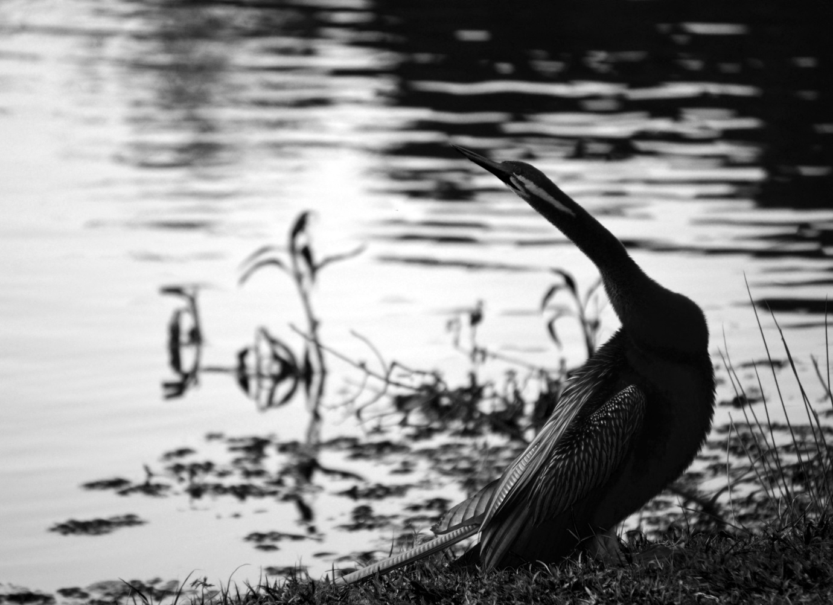

The Ulysses Butterfly
Do you see a savage Incan empire of all conquering yellow flowers
Down my suburban street?
There is a blue butterfly hiding behind every golden mask
The fury of the storms is etched into every gentle wing
The madness of the scorching sun...
Hide from it in an orange frangipani tea cup
Flora, Vertumnus and Pomona shall tell you a fairy tale
The chickens and the coconuts are busy
With their earth song practice in the backyard
My soul is wingless and moonburnt
Saffron-cloaked Hecate, the Light Bringer,
Guide me on my Persephone path
O Carian sorceress, give me the keys to my own heart
Don't envy the blue butterflies
They are all soul, spirit and wishes come true
My depression is a grotto deeper than the Mariana Trench
I am colorless and bony like Saint Death
I eat God like creamy scrambled eggs for breakfast
I read the Book of Life in my airless pain coffin with
My mother's large turquoise ring as a psychopomp
An army of bees is guarding my life-in-death
I am finally home, I am all crystal

The Crocodile Heart
The murk of crocodile skins: which starry eyed elves wanted their soothing chilly breath at twilight?
Pluto, Ouranos, Neptune slowly burn you till every starburst of your bone calcium is returned to a mangrove lined lazy river
Your death, the unquiet obsidian sheen wave of your death
Meeting another torpedo wave of carbon dioxide of a mighty crocodile heart pumping red life and orange juice for breakfast
Why life? Why now? Why the purple prose of bougainvillea vines and crushed mangoes by the roadside?
Love, a stupid green parrot that won't shut up, cruelly glues your cells back together under the glare of a Mary blue sky
The savage, unholy aroma of ripe mango mother flesh is singing to my lavender sunset clouds
Why must life come so close when all you want is to die?

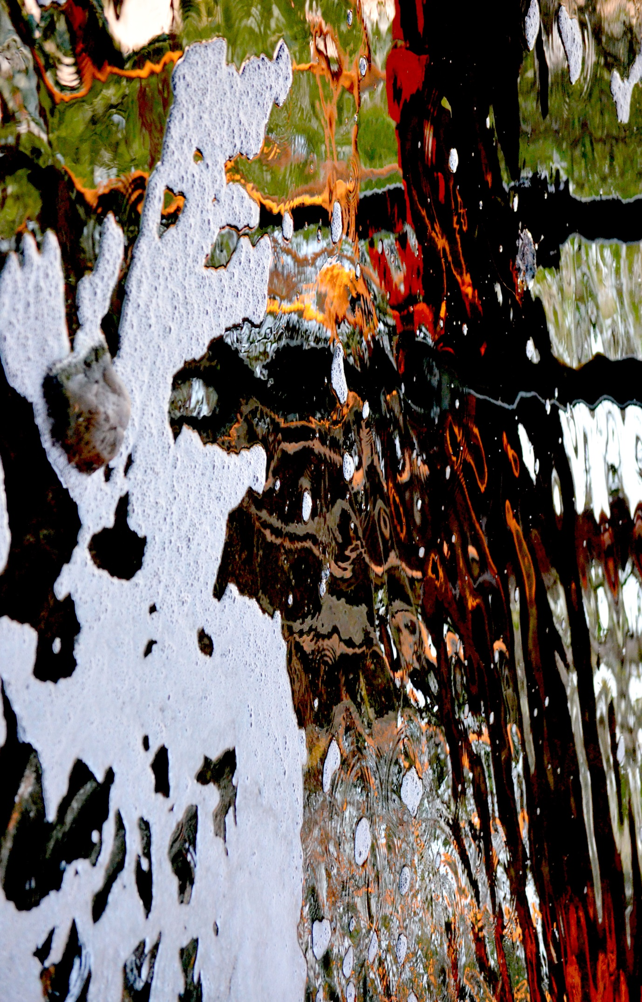
Sugarcane Burning
''O taste and see that the Lord is good: blessed is the man that trusteth in him.''
(Psalm 34:8)
All this maddening cinnamon donut sweetness
Is being offered up to the elves
While we keep circling around green sugarcane fields
Amidst silent lilac hills, languorous as ever
The twilight sky is sprinkled with coppery dust
The air is consecrated with marigold garlands
The sweetness of God, the honey of blessings
Up in the smoke, up in the smoke
Raspberry and white chocolate scones will be on the shelf
Vanilla and sugar drizzled over bread, fresh blackberry jam
The smell of soothing peppermint and warm woody cloves...
Barachiel is scattering invisible white rose petals
Over my tropical emerald princedom

Sea Turtles and Death
I imagine death should be like a gentle
Great Barrier Reef sea turtle
Diving into azure clear water
Bleached white
Coral islands of shining souls
Then an awful, awful descent down
The bottom of the sea
Towards the blue coral forest
Now a big shiny black fish
Is wearing your face
Your antiquarian New Guinea dance mask
Now you are a wrathful deity in flames
Guarding a white lotus
Maybe a demon
Maybe a gate
Chapter and verse thrown in
And I'm still sailing, sailing
Towards green islands
Sea turtles and death

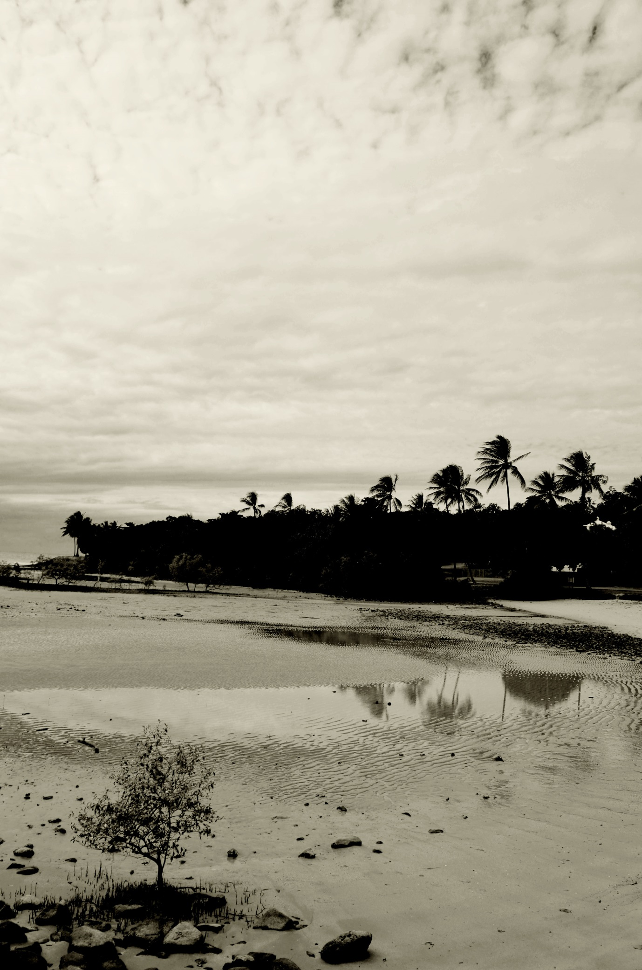
Devil Dimensions
Aum
Bhur Bhuvah Svah
Tat Savitur Varenyam
Bhargo Devasya Dheemahi
Dhiyo Yonah Prachodayat
Every twilight is an opera sacra
Or shall we call it
A Rococo masquerade ball?
The river puts on an evening mask
Of luscious glassy blackness
Or is it a priestly obsidian fire?
Another web of blackness
...dark fractal madness...
In the icy lake of non-being
The terror-horror-error of Lemuria
Is slumbering in the Ring of Fire
The grief feels oceanic in the shivering leaves
Evening after evening
A Lamb offers the heart
As a burnt offering
Filling it with the might of a thousand suns
Under the shimmering stars
From his home galaxy

Green Tree Frogs
Another nightly ascent up the stairs towards my solitary bedroom
Slightly tainted with opiate night perfumes, glistening green totems await
O souls beyond the time before time was time
Is there a bright future ahead?
Only the note of B flat spills out of nocturnal batrachian depths
Strange birds are howling and the black river is almost comatose across the road
There is a mauve, antediluvian horror clinging to my window pane
Green tree frogs, watch my sleep as I turn into a star
I rest in the abode of Orion and my body melts into sweet smelling lilies
Keep your sorceries around me like green jade amulets
Trace your rainwater sigils around my bed
Leap into my dreams and teach me your purple magics
O pleasures of the nightside borderland
O silly little green things

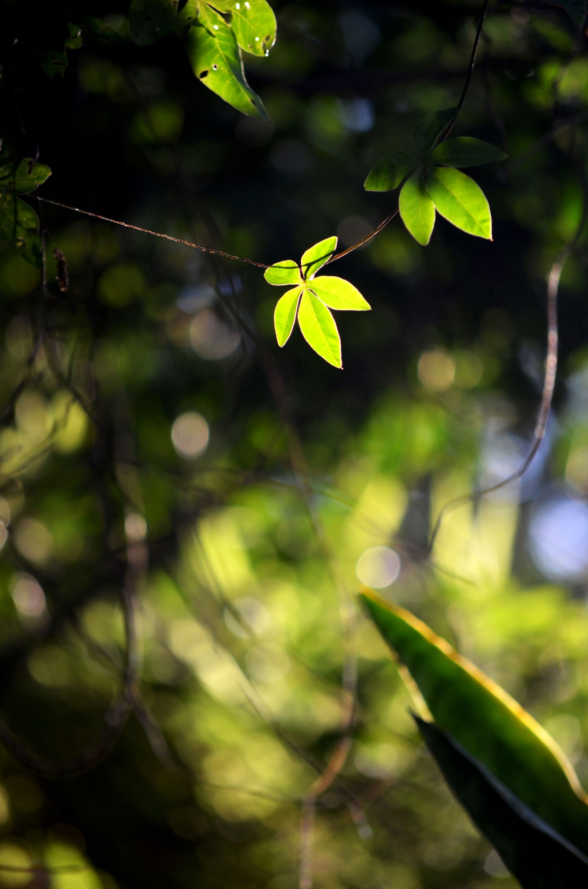
The Moon Man and Emu Eggs
The full moon is a dead crow
Picking away at my skull
It's a monstrous plastic glamor feeding lies
I've been dying all day
Each moon ray is painting
Blue and red lines on the old sarcophagus
Inside my heart

There is an emu egg hidden with
Incandescent, pulsing, breathing feathers
At dawn the emu egg will burst into flames
The moon is a bad, bad man
Now I'll light a small fire each morning
I'll decorate myself with red ochre and call up two lions
I'll make a torch from a stringy-bark tree

The Moon Man will stay out of my path
Lest I walk into the sea,
Take off my coral necklace and curse the world
Or kick up an icy ring around the moon by my rain dance

Oh, fight the pain

Fight it

The Witching Hour
The twilight is dissolving into tremulous birdsong
Of a pure-note hot chocolate heart
Remember how they gore bulls in Spain?
The blood gets spilled and the earth is fed
Remember those who came before us
Remember
A Lamb is opening the wrist to release

A pink sea anemone

A rose bubble tip prehistoric chrism of tentacles

Eating at the weary landscape
Cauterizing every dying backyard
Feeding the intergalactic ocean blood gift
Into the vein of a black river
Nourishing the flow with star tubes
Out of the bones
The crickets are buzzing – they have scribed everything
The mauve toxin has seeded light

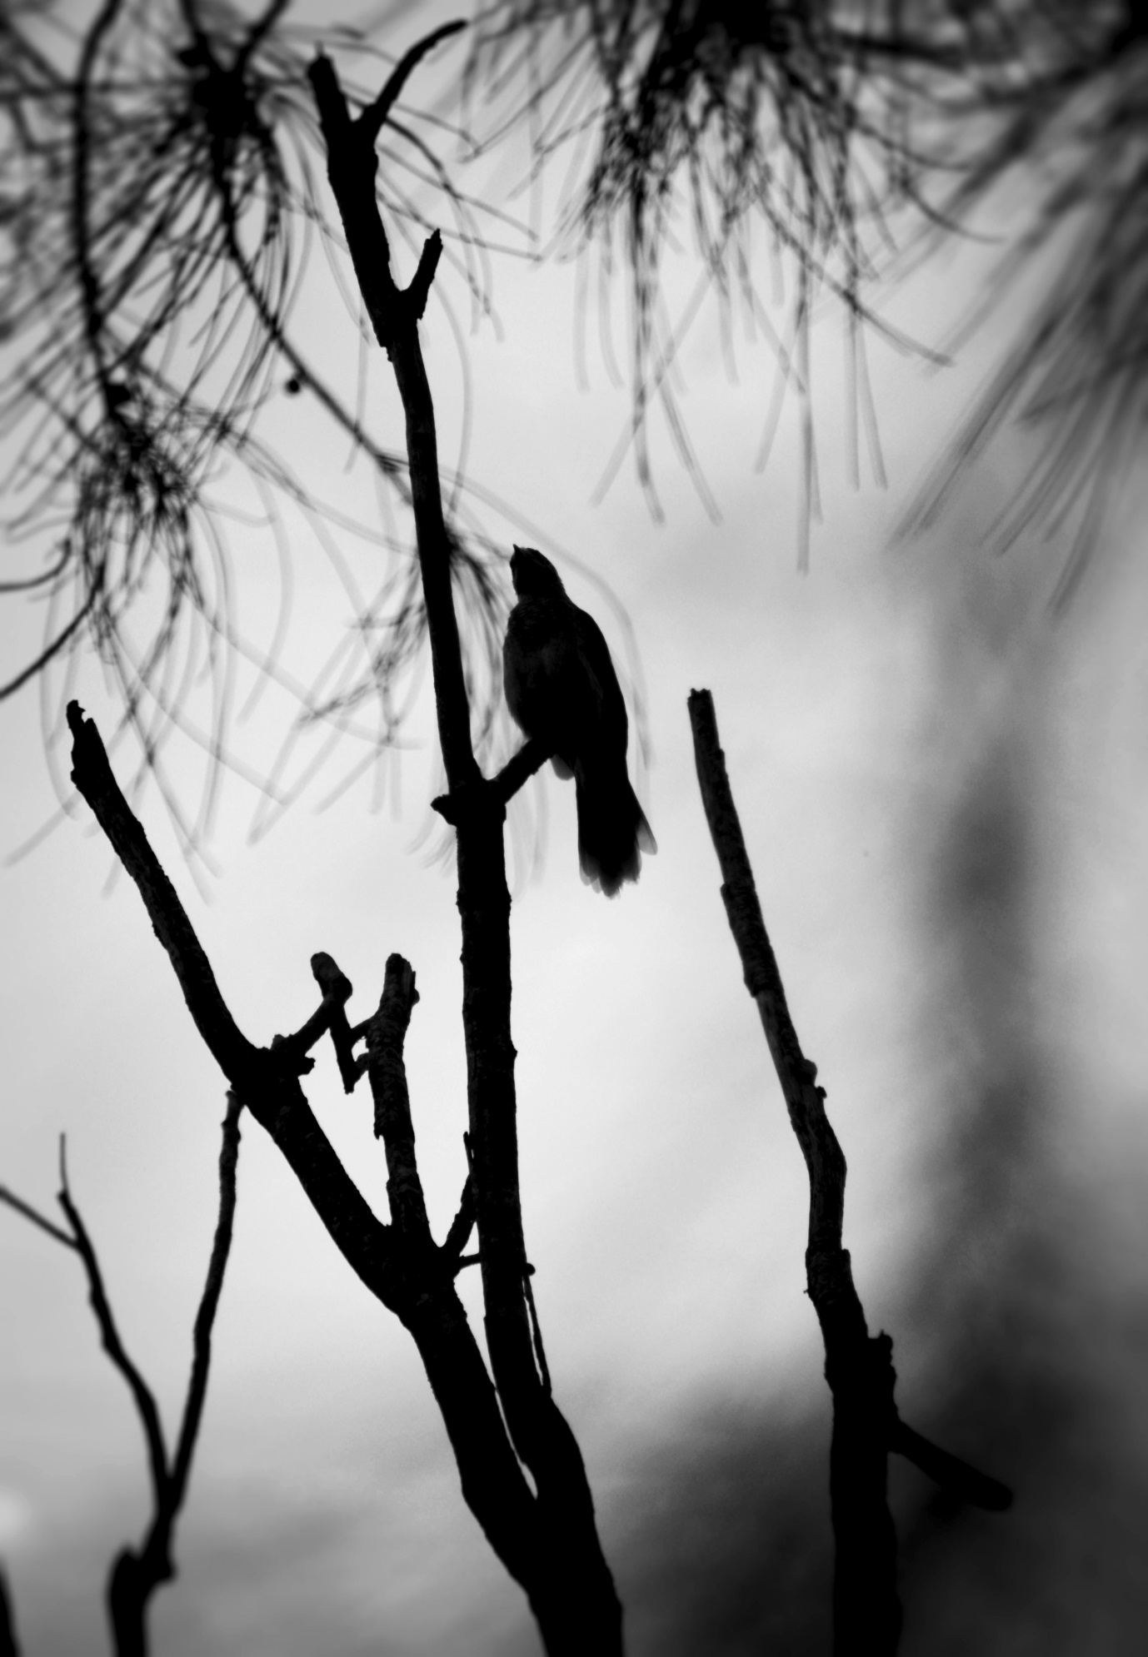

Christmas Trees at Smithfield Central Doctors
"...in spring, the most delicate feathery yellow of plumes and plumes and plumes and trees and bushes of wattle, as if angels had flown right down out of the softest gold regions of heaven to settle here, in the Australian bush."
(D. H. Lawrence, Kangaroo)
Paraboloid totems of evergreen hope, upside down
Sparkling white trinkets, sparkling white dears
''What do we need to do now?''
You ask
I got my husband's winged blue stone gift around my neck, a dragonfly
Isn't my green dress an evergreen kingly shroud?

Both stormy and luminous, the cuts on my arms are still caked in dried blood
You are sad: your heart bleeds into mine with a bit of emerald dust and ruby red sunrises
The Doctor is the Rose; I am the Flame
You are all marble, Plato, self-contained
I am grotesque, decaying, Lilith-born
My scars are trim poodles

Whose slightly wolfish eyes
...just for you...
Will bleed a blazing cornucopia of yellow wattle sprigs
Doctor, your heart is a gold mine and joyous as Spring

Death is but a Sunset
Death is but a sunset
I have already risen with Orion
For I have glorified the Immortal Divinities
During my brief tour of duty in your world
The darkness around you will only grow stronger
But love will win in the end
Fear nothing and follow the light amidst the crimson terrors
Seek and serve the light until your last weary breath
Weave your blue gossamer garments for the next world
Find me in my poems, find me in the scent of pure lilies
Find me in the mad fury of every sunrise and every gentle hue of the sea
I am a red fox electron, I am finally home with my own kind
Remember us during your times of suffering and pain
We shall serve you together with the Creator because there is no death

Diego Rivera and Space Kids
From a lilac splashed canvas
Aquamarine eyes are boring deep holes
Into a black onyx oil field of my larynx
No me diga
Where these space kids come from
And why
No me diga
Aquarian alien eyes, Aquarian alien souls
They must have heard some clarion call
Or the stench of Terran blood offended an unknown god
Rivers of blood had watered Earth like never before
Hello, little octopus brother

Blue Cloak of Isis
(For Carmel Glenane of Atlantis Rising Mystery School, my Reiki teacher and spiritual mother)
Star of the Sea, dolorous and Byzantine
Throw your royal blue cloak over me
She who weeps, La Llorona in La Casa Azul, paint my heart gold
Under a Mexican prehistoric cobalt blue vault of heaven
The blue! The blue! I am spellbound by the blue!
The lapis and lavender blue shining of a Limoges porcelain Mary
Blue lotuses on faded old Amarna tiles whisper me tales
Binding me to the secrecy of an ethereal blue mystical rose
Azure tropical waves caressing a shore strewn with white coral
Bring Lady Isis into my sea turtle guided dreams
Sky blue rays and fiery blue flames, walk with me and scribe my destiny
On your crystalline turquoise tablets in the etheric Gothic
Turn me into your pure sapphire light
I am swooning into the soothing blue of every iris and cornflower
The strange bird that had been singing all along in my heart
It was blue

Mercury Transit 11-11
Many a noble traveller will remember
The alchemy gate
A barely audible cricket sound
During a blissfully cool tropical night
At the edge of the civilized world
The Rainbow Serpent is awakening
To pour forth violet light
In electrical and magnetic ringlets of the ether
My golden rings cannot discipline
Their dancing electrons much longer
In the bedroom, fussy pale gheckos
...nocturnal Paracelsian radicals...
Salute Hermes with relief
Now the walls are open gateways
For a flow of silvery light

On Hidden Sophiologies of White Cockatoos
What strange hierophantic picture language do such heavenly creatures speak?
Which celestial abode birthed your dazzling white magnificence?
Do landscape angels send you on my way with a missive every evening?
Have you glanced hidden temples of light within jungle lianas and fruit dove sanctuaries?
Is it you who helps the fledgling paradise kingfisher find its way home to New Guinea?
Your delicate wings brushed aside the sugar factory canopies of glossy rainforest leaves, ever hungry for the sun.
You've shed grace on the cruelties of nature and sang to the strangler figs slowly suffocating a living tree in its vampire embrace.
The sacred architecture of the forest with its Gothic sun ray seeking spires is an open book to you.
You saw the Rainbow Serpent sacrifice himself in the Barron Falls and become an ever living presence in every steep granite gorge and soothing freshwater creek.
What of your Nemesis? Devil Birds? Black Cockatoos? Appalling and discursive epistemes, they weave their dark magic into the Meissen porcelain of dainty seashore shells.
No creature or landscape invisible shrine is ever at odds with the Earth's visionary geography:
We walk through the onion skin of sacred sites into the stars.

Enténèbrement
Ecchymosis of my spidery words
Lactates your pallid imagination with scarlet stardust
You say I'm morbid, I say it's love
Give me dark arts, give me purple ruins
Each descent into the Enténèbrement
Makes me a gold baby born in blood
I got nine Hydra heads, you got mortal bones
The pitiless lone sea chants my words, I merely spill the runes

Saturn's Tears
''Life is rock rearranging itself.''
(Starhawk)
Antiseptic, sterile
Bone clinic whiteness
Of the surf
Seashells
Paper thin or lavender skeletal
It's the frightful radiolarian symmetry
Of the great ocean death factory
Slowly, slowly
Calcium is being to reduced to crystal
Now the crystal of Atlantean bones
Is a pale pink sea shell by the shore
Molten lava rock by the sea is filled with corpses
And vanished cities
Neptune's commandments
Still being sinned against,
Our skulls are still Atlantean
Now crimson, now white,
Our bones are honeycomb tombs
Vaults of ghostly barbed wire imaginings
Ever Christ-like
The coral bleeds into the blue

April Lyrid Meteor Showers
The stars are falling in
Pictish alphabet swirls
The winter is being conjured in
Goddess-Summer
Hail and farewell
Hail and farewell
Purity dwells in every sugarcane emerald ray
The Gods abide in the fields and the silent black river
I luxuriate in the feeling of home and the darkness of death
The amber glow within
The heart of the light
Is still in the gentle rain
Each drops inaugurates St Brigid's crown of candles
With the goatskin madness of Lupercalia unchained
I glimpsed a wolf from the fiery realms of Azrael
The Grand Architect of the Universes
Is practicing his tasseography with eucalyptus leaves
The sound of flutes, pan-pipes and dulcimers
Is dancing with the palm trees blowing in the winds
The stars are coming alive in apple beer and mead
Ablaze with glory
The sacred iron falling from the sky ignites a blue flame
...a pentagram over the heart...
And the unity of the entire creation in an event horizon sphere

Wesak Full Moon and Aldebaran
I dreamed I was flying between the horns of Taurus
Cold and forlorn in a senseless starry abyss
I was seeking the red hermitage of Aldebaran most desperately
Amidst the desert of neutrinos, protons, black holes
Finally terrible cosmic darkness gave way to warm light
Bright by their birthright and sanctifying
The Pleiades must have been guiding the way
The Seven Rishis of the Great Bear are still
The living anamnesis of the starry Time Mother
The accursed Earth wheel is still spinning
I am weaving light from red hibiscus flowers
It is Minerva's work
Buddha's diamond light from yesterday
Is still pouring forth in every crystal
Deep within the earth
The Invisible Ashram is adorned with sentinel lights
And fires of the Lamb's Victory

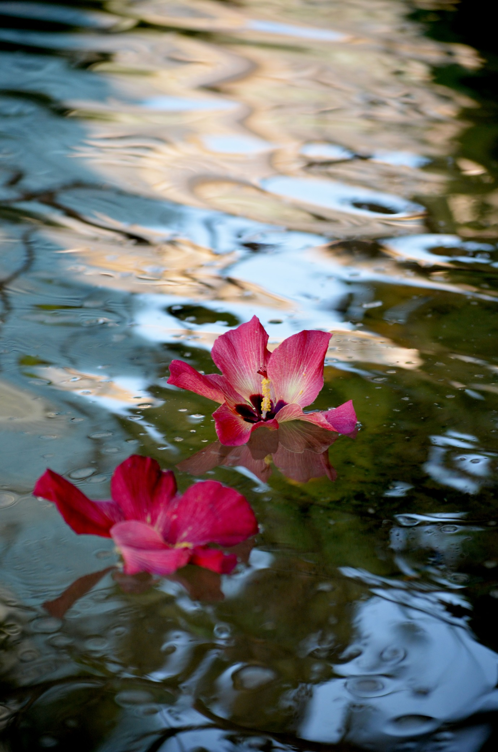
Beauty is a Line
''Color is a power which directly influences the soul.''
(Wassily Kandinsky)
Each weaponized laser light bubble of the golden drink
...from the sacred land of Cimmerian shadows...
Crack open the skull towards a mirror world
Does God or Lucifer rule this place?
Like a tropical strangler fig
La Traviata is growing deep roots
Into Grand Café columns
On every elegant table
The lilies and the roses
Begin to awaken
To Aurora's golden light
In the glass
More light! More mirrors!
More new worlds yet unseen!
Up the stairs, up the stairs
Zephyr-born
One melts straight into Kandinsky's lines
The black mass of color is waltzing
Into a rose in every pure vein
My fin de siècle
Pretty postcard is dripping with blood

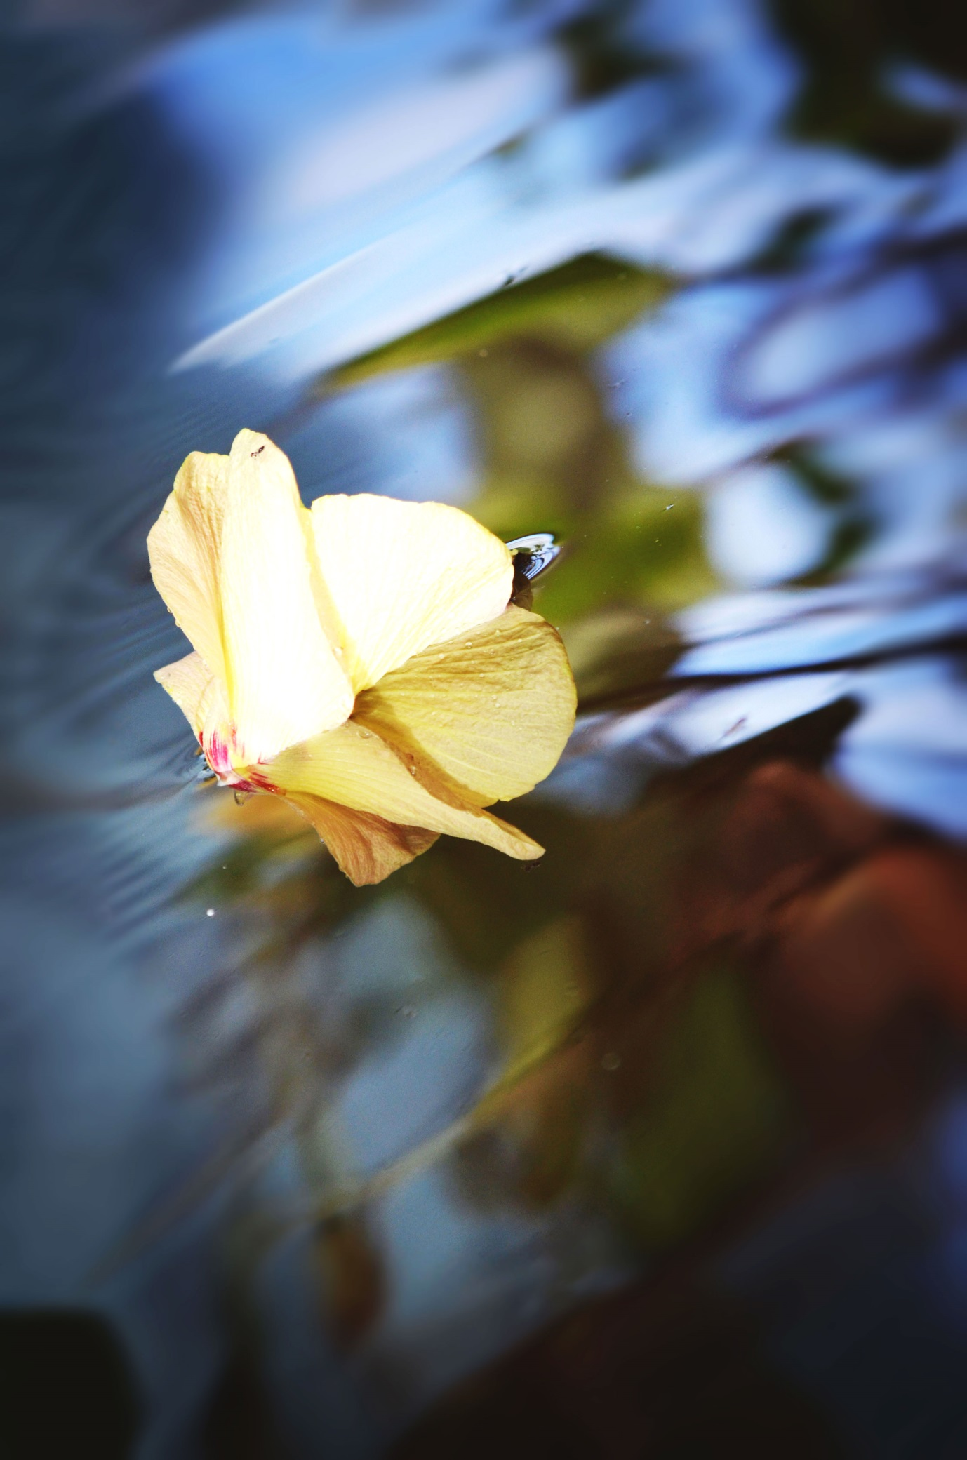
Gold
A vein of gold is stepping out of colliding
Neutron stars in a blazing cosmic fire into
My longitudinal heart waves
Gravity is a rainbow snake
I rise over all black fractal
Molecules of pain
For I am a magician
Born into darkness and raised
Between the twin pillars of blue and red light
There is only love
It's an ever grinding atom smashing factory

The Lion Heart
The Southern Cross
has exorcised all princely
sanitised shrines to mass
consumption oblivion
Americanness
has crawled back
into the Atlantic
English bakeries are spinning
and weaving the heart
of the hearth so tirelessly
The joyous magnificence
of humble steak and ale pies
Does St George watch
over the brown gravy?
Does St Brigid bless
the flaky warm crust?
The heart of the hearth
Verse forged in the stove
Glittering green palm trees
are gently swaying
in the breeze to the
invisible blues rhythm
Bakeries and palm trees,
daisies and dandelions
are sunbursts from
the Lion Heart
The heart of the hearth
The Star Goddess radiates
many invisible threads
like brilliant ideas
or the spokes of a photonic
wheel
Between Sirius and Canopus
''Every nature, every modeled form, every creature, exists in and with each other.''
(The Gospel of Mary)
During another torrid tropical night
The maiden Sophia enters a blue-cloaked dream
The black muddy river hungers for starlight
Across my lonely country road
With Orion, I rise in a strange blue Buddha land
Cold stone temples...I am lost, I am lost
Until a golden haloed Madonna Oriflamma
Gives me gentle purple wings
Tropical summer madness opens a vein
Between Sirius and Canopus
Tropical summer sadness bleeds
The sweet frangipani salve at night
The Rainbow Serpent will soon cleanse the heart
With every fiery wet season storm
Is there a string of pearls between Sirius and Canopus
Blazing so fiercely at night?
I long for my opalescent souls left behind
I will give them every precious pearl from the summer night sky

Emerald Dreaming II
Venus appears above the lilac horizon
The battle cry of crickets is a regal dolphin
In the lush green rainforest
My heart petals unfold into an emerald spiral
Paint your prehistory sea green
Burn your breviary
Melt into a piece of bright green Burmese jade
Swoon into the rust of copper
Old as Aphrodite

Jean Rollin
Visconti, Godard, Truffaut, Clouzot
Millions of women wanted golden locks of our goddess Bardot
Such illustrious names on the covers of the big magazines next to
Tarot packs and sandalwood in newly sprung occult bookshops
Sanctus, sanctus
I bow to the new Old Masters and their mauve magics
Yet I don't want to be Sophia Loren or Michelle Mercier
I don't have the spirit of the indomitable Angelique or Italian chic
Imagine a tender supple breast cinematographically caressed
The moment a captive pale maiden steps out of a purple coffin
To gaze at the sun by the sea is The White Goddess condensed
Her transparent stola of orange gauze is almost a priestly robe
Black drapes and crimson silks, sweet sapphic delights, old cemeteries
Imagine a world where all reason mercifully sleeps and the ritual reigns
Beautiful images roll which sing a curious lullaby directly to my tired soul
Watch the avenger Brigitte Lahaie wield a scythe like Saturn
I'd rather be a vampire who is a true child of Neptune
Always rising out of or sinking into the sea by the beach near Dieppe
Each celluloid immoral tale has carved this lonely shoreline
And white chalk cliffs deep into my cells ever hungry for beauty
I'd rather be a Rollin vampire on the phantom silver screen
Where the iron rose of imagination always blooms
And foreboding nakedness always fascinates
Paint me a vampire in a surrealist black sabbath or Dadaist dream
Kidnap me into the timelessness of the fantastique at knifepoint
I care little for Vietnam and dizzy rioting pups who could read
Neither Lolita nor Proust
I'd rather be a Rollin vampire on the phantom silver screen
Mad Song of a Vestal
Red poppies, red poppies
Slave, carry them away at once
My brother, my brother, what have you done
Ah, how hideous every red flower is
Their murderous roots buried my Sibylline whispers forever
My brother, my brother, what have you done
Tarquinius rides out of every red chrysanthemum at midnight
He's a tiger bright Helios and I'm burned to a cinder like Semele
My brother, my brother, what have you done
Our terracotta warm Etruscan villa is now burning with red orchids
I see bleeding roses everywhere: a gashing Orcus wound on every wall
My brother, my brother, what have you done
His Martial crimson cloak and iron helmet with feathers
Still blaze with battlefield sunsets and bull's stardust blood
My brother, my brother, what have you done
His touch is a searing red anemone in April as the Ram rises in the sky
His kisses are blinding bright marigolds which bloom all summer long
My brother, my brother, what have you done
He says we are to love each other like gods do
Vesta, Vesta, Vesta, hide me in a pure white shroud by a quiet spring
My brother, my brother, what have you done
You threw me on a spice-laden altar like a burnt offering
My hair is aflame with Medusa serpents, my pale skin is peeling off
My brother, my brother, what have you done
There is poisonous red coral tree growing in my swan blood
Vesta, Vesta, Vesta, bury me with a blue sapphire over my heart
My brother, my brother, what have you done

Hathor
Out of overlapping waves, ripple over ripple, and sea foam
A celestial blue gem is born
I do not seek this stone in dead temples or far away countries
The Mistress of Turquoise is a living diamond
Crushed mangoes by the road offer up
The aroma of her sweet golden skin to Ra
Her malachite is in a billion of leaves of jungle canopy
Soothing my spirit ravaged by the fury of Sekhmet
The Mistress of the Sky draws forth her sistrum
Piercing the very depths of my heart
So I become Hathor myself
Rising as a gum tree with the Southern Cross
With my new golden horns
I am Hathor, I command the shining spirits
Whose immortal milk
Can vivify an emaciated land

Villa of the Mysteries
"At the end of the ritual/Up comes a goblin"
(Ted Hughes)
The blood moon is your ally tonight
It still singes the red strands of my hair
Brother-lover, am I your new baby
Born in blood?
I feel antediluvian monsters
Laugh at the plankton of my cells
I still love the mantle of darkness
You gave me
Yet my curses and storms disturb you
I'm not your experiment, I'm not your precious
Porcelain doll. Your barbed wire is still
Stuck in my throat. Your dog Latin is
Still lost in translation
Your love still makes me want to die
Century after century
Body after body
That other thing has grown stronger in
My blood
It fed on the unstoppable machinery of
The world and time, blue ribbons and all
It fed on many unfathomable star arabesques
Meteoritic iron and azure ocean waves
It fed on Wagner interludes and the hydrogen bomb
It fed on volcanic plateaus of desolate Auvergne
And the savagery of Australian sunsets
With each cut on my skin
I crush your Brotherhood like a walnut
Across time and space
Even my frailty terrifies you, doesn't it
I still wear white, I prophecy, I burn Nag Champa sticks
I'm, I'm, I'm

Venus Rising
The sunset has shed the blue sapphires
over the parking lot. Drinks after a movie.
It's a nice place. Civilization flies a flag
of timid complacence and neon lights.
Only a bright star rises over the dark hills.
You must feed yourself to the moon wolves
hiding in the ancient hills.
Wild bulls and storm terrors live there.
You must become skeletal. Dead but ever living.
And there is a golden lynx guarding a bow
you aim at the heart of the Milky Way
in those dark hills.

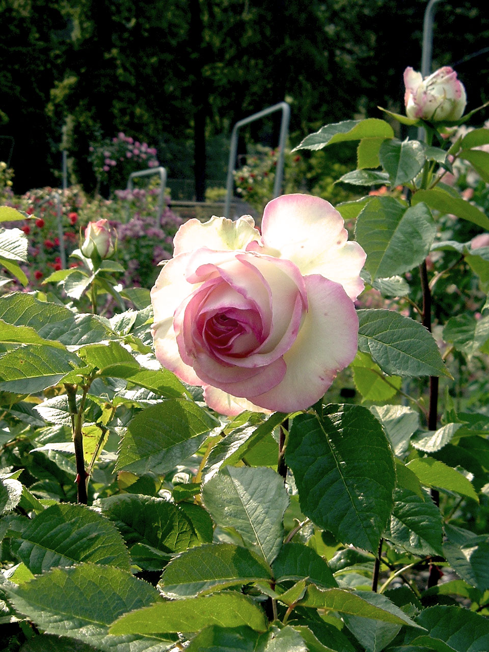

Lepus Syriacus
Did my pain first waltz through blue-white arches of Ugarit
Or was it brewed in the stone cauldrons of a nameless desert city
Were the wounds on my skin a form of starry cuneiform
My brother Osiris, my husband Osiris
Your club and your spear and your priestly tiger skins
You should have let me remain a pale yellow star
And leave my bow and arrow in the Temple of the Obelisks
In a constellation of citadels under Mary's blue cloak
It's the humble smallness of Aleppo hares
That stills and soothes me as the timorous Time collapses on itself
Sky-earth hares, scorching desert hares, gentle hares
And Orion the Hunter, marching through the triple gates
Would you enter the mind of an Aleppo hare
It must have all begun with the Shining
A great ethereal Shining in the mists of prehistory
A half-forgotten dream which has become a nightmare
Trickling blood and semen and nightshade gauze
Pain is a garden of velvety black tulips and red baby roses
Under the neon lights, I can feel our Gods coming back
Now they murmur, now they roar in the fairy land of museums
Lost amidst Florentine Madonnas, Warhols, Max Ernst
Find the safety in the unassuming simplicity of Aleppo hares
The breast of Orion the Hunter shall birth a new world

The Other Woman
She slings an orchid projectile at me
Should I drown her cats?
Incinerate her panthers?
Like an Italian widow
She always wears black but
Orange silks would suit her better
With maybe a little wet green pike
Nesting between her breasts
Shining like quartz into another life
Another story, another canopic jar
Or is she the sad Isis moping around
The rain gardens along Divisadero in
A black cocktail dress without any pearls?
Wrong address, wrong millennium
You eavesdropped on a wrong dream, dear lady
You came too late
I wish you galloped into that accursed villa
On a sulphurous white-red horse
I wish every Ionian death shroud dress
He bought for me was meant for you
I wish my lamentations
Would have been your festive songs
I wish he loved you like he loved me
I wish Pan's walled garden remained
Under the red and gold face of the sun
Instead he buried my voice in a black cauldron
And slammed my crystal coffin lid
I am still groggy from my sleeping pill
You should have been me
You should have been me
You should have been me

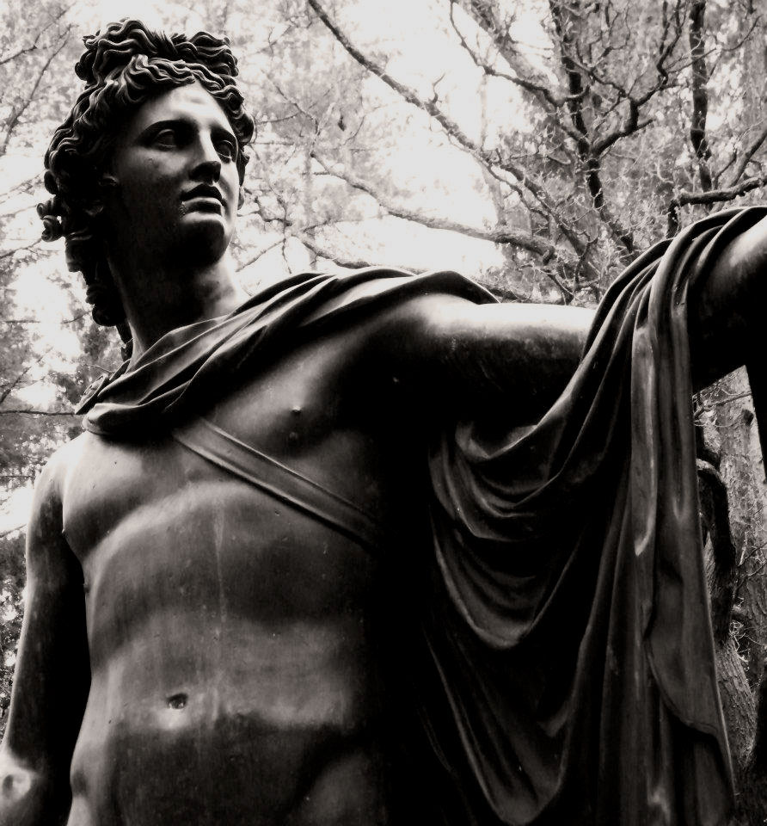

Full Hunter's Moon in Aries
The sugarcane is growing again, sun-fed.
The baby-ish sweetness of the fields invites one to hack forward with a surgeon's scalpel.
Imagine a piece of birthday cake taken to the grinding iron rollers of a sugarcane mill.
Sugar is love, but the sugarcane is sharp like a blade of iron.
Can sweet things be red and martial? Was the Lamb not born under the last light of the Ram?
I am tired of a cold steel dagger in my heart; I may well be a silly lamb.
Yet if my heart could bleed, it would bleed blue and Neptunian.
Or, perhaps, it's the sun of lavender fields blazing in purple
That will bring our souls to a sea of starry amethyst.

Knight of St George
Where are you, my love, my love
Must you always be so stern in your imperial St George regalia
While I am growing pale and wan like Rhiannon
Where are you, my love, my love
Did I tell you about my fiery lava land of the couzes
To the west of the river Allier
Where are you, my love, my love
Find the couze of Ardes and the couze of Chambon
Put me in a raised granite chapel with a pouring waterfall
Where are you, my love, my love
Let me never wake again until halophile sea plants
Marinade my still heart inside every otter, volcano, rain drop
Where are you, my love, my love
Once you defeated time and death to find me
And I stupidly fled
Where are you, my love, my love
So you erased everything and let me see the mauve realm
As a fountain of blood began pouring out of my heart
Where are you, my love, my love
And you said there was little time left
When you showed me an M mark on both of our hands
Where are you, my love, my love
Am I ugly? Do I repulse you after everything men did to me
Then be cruel and say something dreadful
Where are you, my love, my love
There is your beautiful grand empire forever silencing me
Like a hydrogen bomb would forever silence all Pays d'Issoire trout
Where are you, my love, my love

The Order of the Red Hibiscus
I saw a sun being
arrayed in purple
celestial light hold
a five petalled
red chalice
Alcyone's blood
is petrifying
in the diamonds
of Polaris
like an insect trapped
in amber
Will and Love of
the Order of
the Red Hibiscus
is a river of blood
slowly filling up
a five rayed
flower chalice till
the red eyed
winged Bull
unites with
the fiery Dove
raining starlight tears
on our red clay soil

In Memory of Tracy Twyman
Life and death
Two hissing snakes
I dreamed of meeting her
By a black subterranean river
Was it Heaven or Hell
I felt I was frozen in an unknown terrain
No Hecate's torch to guide my path in this misty limbo
Never-never land that had always flown in our veins
The blood gift, the blood curse
The Devil's breath has followed my path too
I felt its luminous strands weave ancient pain into my soul
On the streets of New York or St Petersburg palaces
My Persephone, my obsidian dart underworld chum
There is a langorous black tropical river by my house in another world
In my dream, the dragon born prophetess seized me
To upload a serpentine shining photon of knowledge into my brain
This is how things are done in a parallel realm
I tried to set myself free till a dark deathly mist carried her away
Like a hungry ocean wave snatches a gentle seagull with a broken wing
Here north of the Capricorn, the sea is perennially seeking a small death
The poisonous vine of knowledge is still growing within my old soul
Our dark orbits merely glided past each other like proud black swans
In an Old World pond with a marble Neptune statue
Yet some of our stars are the same and we'll talk again

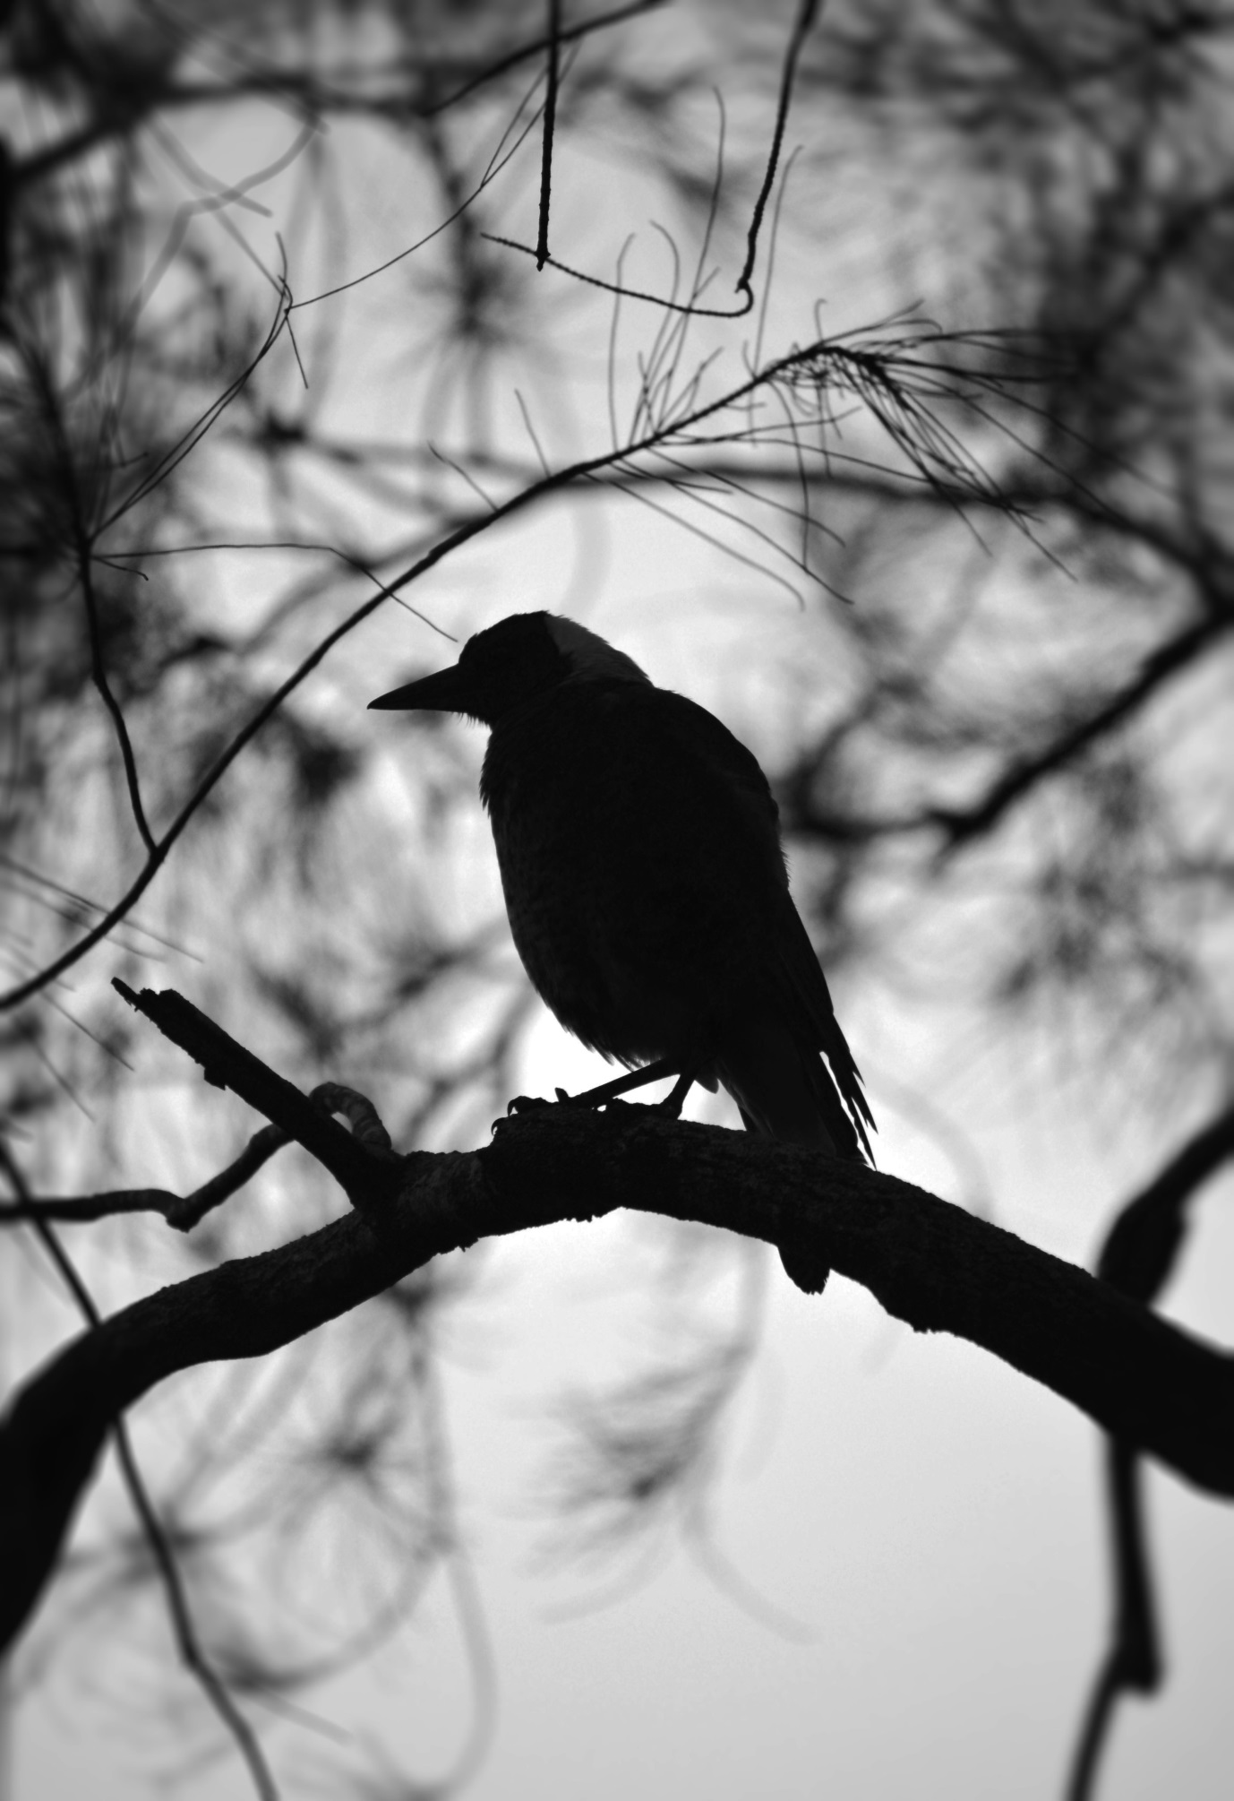

Photographs, Photons
What am I but a soul weary echo
Gliding through millennia of hazy lives and shining stardust
My camera cages light
As if light can be captured: how obscene
I set pearl-laden words free
My oysters, my doves, my bullets
I imprison dancing photons in wooden frames
Dueling planets have only scarred my horoscope
It's a silly sheet of bone-white paper
A royal marriage of Venus and Jupiter
Has made me Lady Luck with golden locks
A white shrouded shade playing one more game
In the Tao of the Ten Thousand Things
Now I am silent
And you must weave a strand of Ophiuchus light
Until we meet when the stars are right again
O gentle reader, it is your turn

Notes
Patrick Zeigler is an international teacher and wonderful human being in service for mankind. On his constant journeys he has being helping those who come to him to experience to learn to open up their heart centers and, through it, connect to their true self and consequently connect with their soul and their connection to Source.
Today his seminars are called ALL-LOVE because the class greatest objective is to facilitate the way for people to experience love on every level and in every form. In the classes, Patrick guides his students in a journey of deep healing on all levels as well as to establish an opening to deeper inner portals with his warm guiding voice, and the purity of his soul.
Following his childhood heart desire, Patrick traveled to Egypt in 1980 and had the opportunity to sleep in the Great Pyramid. During the night he had a powerful initiation that would change his life. As he tried to understand the experience he had had in the pyramid, Patrick traveled to Sudan where he kept close contact with an Elder Sufi saint and his community in Khartoum. The combination between both these experiences helped creating the foundations for what we now know as the Sekhem Energy System, also pronounced as Seichim or Seichem.
The Einstein Cross is a galaxy situated between Earth and a quasar 8 billion light-years away creates a “gravitational lens” that bends the quasar’s light, forming four bright outer objects.
Le Théâtre du Grand-Guignol – known as the Grand Guignol – was a theatre in the Pigalle district of Paris. From its opening in 1897 until its closing in 1962, it specialised in naturalistic horror shows.
Throughout his masterpiece, In Search of Lost Time, Proust repeatedly refers to colours as Tiepolo Pink or Tiepolo Red.
The Gāyatrī Mantra, also known as the Sāvitri Mantra, is a highly revered mantra from the Rig Veda.
In musical terms, the pitch of the sound generated by the black hole translates into the note of B flat. But, a human would have no chance of hearing this cosmic performance because the note is 57 octaves lower than middle-C. For comparison, a typical piano contains only about seven octaves. At a frequency over a million billion times deeper than the limits of human hearing, this is the deepest note ever detected from an object in the Universe.
According to Aboriginal legend, emus were creator spirits that used to fly and look over the land. To spot the emu, look south to the Southern Cross; the dark cloud between the stars is the head, while the neck, body and legs are formed from dust lanes stretching across the Milky Way. Physics student and Sydney Observatory guide Kirsten Banks said most Aboriginal tribes told the story of the emu in the sky.
Diego Rivera visited Moscow for the second time in 1955. During his stay in the hospital, he produced several landscapes, portraits of men and women, and a series of Russian children (including Sputnik Boy).
Carmel Glenane, founder and owner of the Atlantis Rising Healing Centre™ & Mystery School, is an international teacher, published author and sought-after speaker and visionary healer.
The Rainbow Serpent dreaming in Aboriginal society represents one of the great and powerful forces of nature and spirit. Connected to water, the Rainbow Serpent is the great life giver, and protector of water, which is his spiritual home.
At the 1900 Paris World Fair, a sparkling wine from Crimea defeated all the French entries to claim the internationally coveted Grand Prix de Champagne. The wine, known as Novy Svet (New Light), was made by Prince Lev Golitsyn, a highly educated member of the royal family, at his wine estate in Crimea on the northern shore of the Black Sea. Emperor Nicholas II of Russia visited the estate of Lev Golitsyn with his family in 1912. He was invited to taste champagne which was produced there. Having tried it, the Emperor said he could see life in a new light.
Finally, scientists know how the universe makes gold. They’ve seen it created in the cosmic fire of 2 colliding stars via the gravitational wave they emitted.

The famous artist Roerich painted his picture “Madonna Oriflamma” especially for the Pact of the World. Thoughts about this Pact too often did not leave the artist, therefore their echoes can be seen in many of his works.
May 1968. Parisian streets are awash with violence and public unrest. In a small cinema, a surreal vampire film causes a riot. The audience smashes up the auditorium, tear out the seats, and chase the film's director onto the street with violent intent. This is the premiere screening of Jean Rollin's feature debut, The Rape of the Vampire.
An outsider of French cinema, Rollin's films are unique and dreamlike. They offer tales of mystery and nostalgia -- of lost love, childhood, obsolescence and seductive female vampires with a thirst for blood and sex. Rollin made strange, evocative and deeply personal horror films. But he was also at the heart of the French pornographic revolution after the abolishment of censorship, and discovered porn queen Brigitte Lahaie, later to star in many of his films.
The White Goddess: a Historical Grammar of Poetic Myth is a book-length essay on the nature of poetic myth-making by author and poet Robert Graves. The White Goddess has been important for writers as a creative, poetic work.
Couzes is an Auvergne word for mountain stream.
''Many individuals on the Earth today are Lemurians and Atlanteans who have returned to participate in another struggle between the forces of good and evil on this planet. Some believe that if the creases of the lines that are visible in the palm of your hand when you slightly close it form the letter ''M'' you were probably one of the children of the Light. A curved ''S'' or ''C'' indicate the sons of darkness.'' (Shirley Andrews, Atlantis and Lemuria)

